Rev. Nr | Data |  | Modificare / Revizie  Modification / Revision |  |  |  |  | Proiectant  Designer |  |  | Aprobat Consultant  Approved Consultant |  | Aprobat CFR  Approved CFR
1
2
3
 |  | GUVERNUL ROMÂNIEI  ROMANIAN GOVERNMENT |  |  |  |  |  | PROIECT FINANŢAT DE UNIUNEA EUROPEANĂ  EUROPEAN UNION FINANCED PROJECT |  |  |  |  | 
CLIENT / CLIENT:
 |  |  |  |  |  |  |  |  |  | C.N.C.F.”C.F.R.” – S.A.
CONSULTANT/ CONSULTANT:
  Joint Adventure Leader |  |  |  |  |  |  |  |  |  |  |  | 
Aprobat  Approved |  | Şef proiect  Project Manager |  |  |  |  | R. Liuzza |  |  |  |  | 02.2012 |  |  | 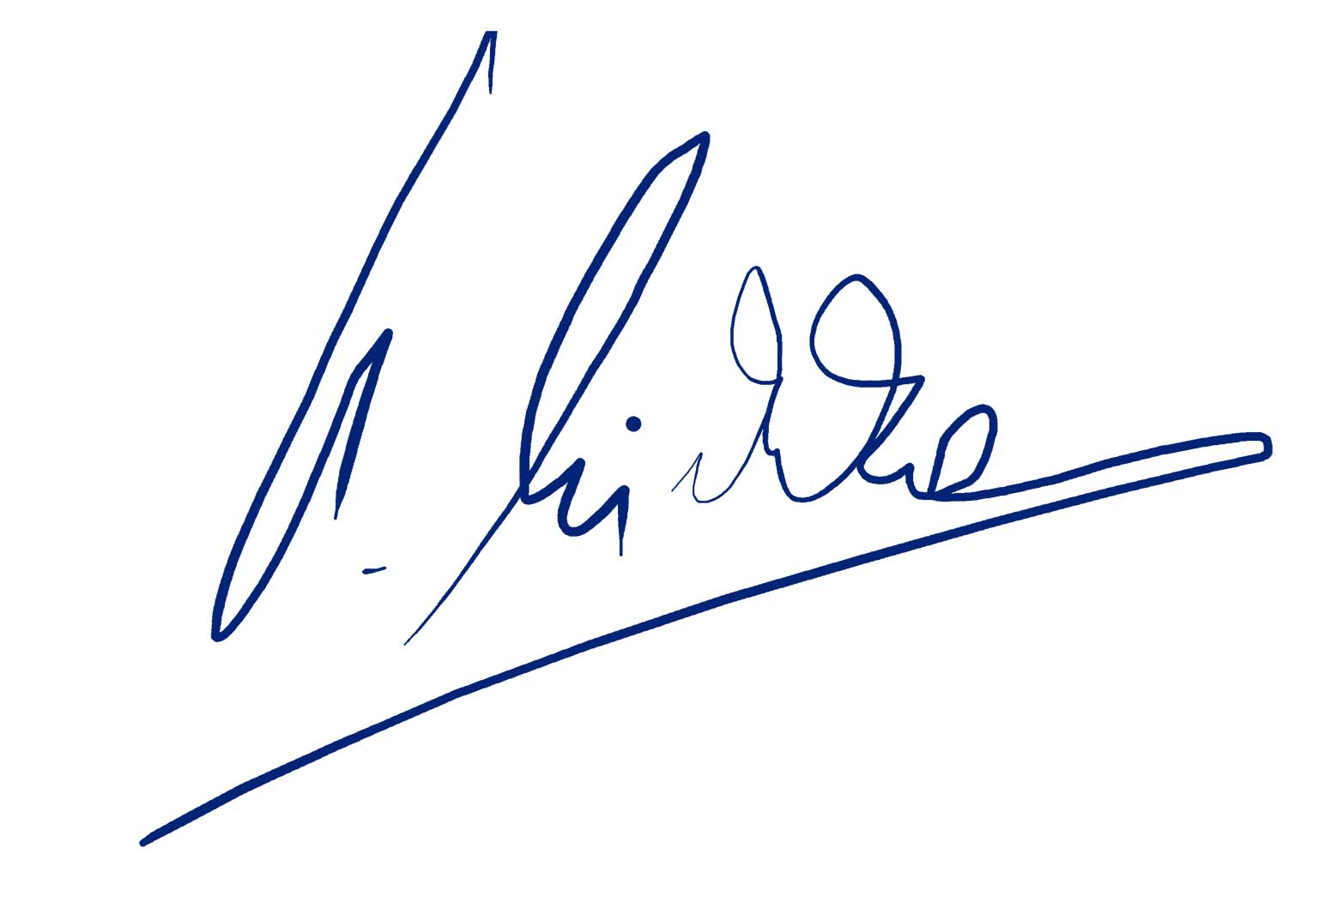
Aprobat  Approved |  | Coordonator Secţiune 1  Section 1 Coordinator |  |  |  |  | C. Gambelli |  |  |  |  | 02.2012 |  |  | 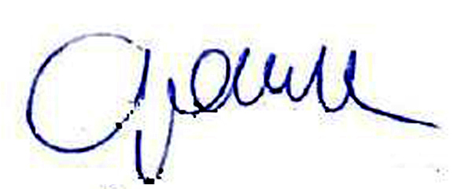
Verificat  Checked |  | Expert Cheie  Key Expert |  |  |  |  | A. Pino |  |  |  |  | 02.2012 |  |  | 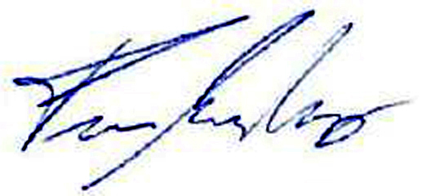
Reabilitarea liniei de cale ferată Braşov - Simeria, parte componentă a Coridorului IV Pan-European, pentru circulaţia trenurilor cu viteza maximă de 160 km/h,
Secţiunea: Braşov - Sighişoara
Rehabilitation of the railway line Braşov - Simeria, component part of the IV Pan-European Corridor, for the trains circulation with maximum speed of 160 km/h,
Section: Braşov - Sighişoara

ISPA – 2004/RO/16/P/PA/003 – Publication Ref: EUROPEAID/121736/D/SV/RO
SUBCONSULTANT / SUBCONSULTANT: |  |  |  |  |  |  |  |  |  |  | Denumire / Title:
 |  |  |  |  |  |  |  |  |  |  | FIȘE TEHNICE  VIDEO SUPRAVEGHERE  TECHNICAL DATA SHEETS  VIDEO SURVEILLANCE
Responsabil Subconsultant:  Subconsultant Responsible: |  |  |  | A. Stanciu-Dinulescu |  | 02.2012 |  |  | 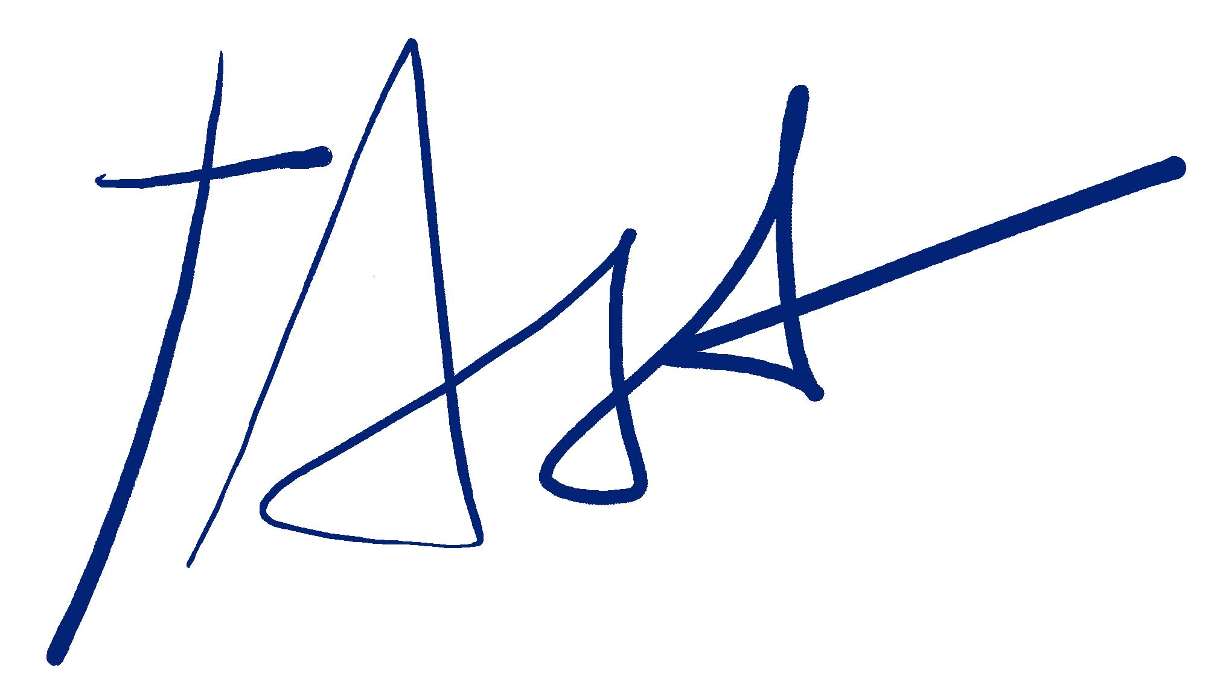
Întocmit:  Elaborated |  |  |  | G. Trifan |  | 02.2012 |  |  |  |  | Object/Lot:  01 |  |  | Faza/Phase:  PTH/TD
Codificare / Codification System:
E | A | 5 | 1 |  | 0 | 1 |  | C |  | 0 | 0 |  | F | T |  | S | E |  | 0 | 0 | 0 |  | 0 |  | 0 | 0 | 3 |  | 0

