VOLUME D20
GEOPHYSICAL INVESTIGATION
SEISMIC SURVEY

Volume | Km from | Km to | Task | Length | Survey Type
D01 | 800 | 1+300 | i | 0.5 | Seismic
D02 | 27+200 | 27+500 | i | 0.3 | Seismic
D03 | 28+400 | 28+600 | i | 0.2 | Seismic
D04 | 28+600 | 29+600 | i | 1 | Resistivity
D05 | 36+800 | 37+300 | i | 0.5 | Resistivity
D06 | 37+300 | 37+800 | i | 0.5 | Seismic
D07 | 37+800 | 38+900 | i | 1.2 | Resistivity
D08 | 10+200 | 10+700 | iii LLR | 0.5 | Seismic
D09 | 300 | 900 | iii | 0.6 | Resistivity
D10 | 900 | 1+300 | iii | 0.4 | Seismic
D11 | 1+300 | 2+700 | iii | 1.4 | Resistivity
D12 | 2+700 | 3+100 | iii | 0.4 | Seismic
D13 | 3+100 | 5+300 | iii | 3.2 | Resistivity
D14 | 8+500 | 11+000 | iii | 2.5 | Resistivity
D15 | 12+000 | 13+000 | iii | 1 | Resistivity
D16 | 15+000 | 18+000 | iii | 3 | Resistivity
D17 | 20+000 | 21+000 | iii | 1 | Resistivity
D18 | 25+200 | 25+900 | iii | 0.7 | Resistivity
D19 | 29+500 | 30+700 | iii | 1.2 | Resistivity
D20 | 36+400 | 36+800 | iii | 0.4 | Seismic
D21 | 38+600 | 39+300 | iii | 0.7 | Resistivity
D22 | 39+300 | 39+700 | iii | 0.4 | Seismic
D23 | 39+800 | 41+300 | iii | 0.5 | Resistivity
D24 | 43+200 | 43+500 | iii | 0.3 | Seismic
D25 | 51+700 | 55+300 | iii | 3.6 | Seismic
D26 | 68+600 | 69+800 | iii | 0.2 | Seismic
D27 | 70+800 | 71+600 | iii | 0.8 | Resistivity
D28 | 90+700 | 91+300 | iii | 0.6 | Seismic
D29 | 91+800 | 92+600 | iii | 0.8 | Resistivity
D30 | 96+200 | 98+200 | iii | 2 | Resistivity
D31 | 1+000 | 1400 | ii | 0.4 | Seismic
D32 | 9+000 | 10+000 | ii | 1 | Seismic
D33 | 14+500 | 14+900 | ii | 0.4 | Seismic
D34 | 20+900 | 21+600 | ii | 0.7 | Seismic
D35 | 27+300 | 27+700 | ii | 0.4 | Seismic
D36 | 29+500 | 29+900 | ii | 0.4 | Seismic
D37 | 32+000 | 32+400 | ii | 0.4 | Seismic
D38 | 27+700 | 29+000 | ii | 1.3 | Resistivity
D39 | 62+500 | 64+000 | ii | 1.5 | Seismic
D40 | 71+000 | 71+700 | ii | 0.7 | Seismic
D41 | 73+000 | 73+400 | ii | 0.4 | Seismic

General Information

Survey Line Parameters
Projected Parameters | Volume name | D20
Projected Parameters | Survey type | Seismic Refraction
Projected Parameters | Task | iii
Projected Parameters | Km from | 36+400
Projected Parameters | Km to | 36+800
Projected Parameters | Length (km) | 0.4
Survey Parameters | Length (km) | 0.42
Survey Parameters | Maximum offset from projected line | -
Survey Parameters | Data acquisition period | 10.09.2008
Survey Parameters | Weather condition | warm
Survey Parameters | Brief terrain description | Medium terrain covered by scattered dense vegetation and agricultural land
Notes:
- Maximum offset is due to projected motorway curvature

See Annex 20/41 (Survey Line Location and Results)

Survey equipment
Data acquisition stage was completed using the following equipment:
- GEOMETRICS GEODE Full Seismic Equipment
Survey type: seismic refraction
- 20 - 80 meters depth (depending on refractor position and overall velocities)
- 24 geophones, 2.5 meters spaced; 11 shots / spread.

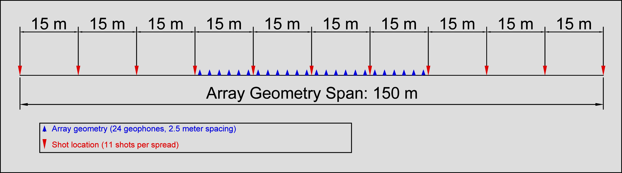

Data Acquisition Parameters

Measurement Parameters
Seismic trace length was set to 1024 ms sampled at 0.512 ms for 24 simultaneous recordings per shot.

Quality Control
To insure reliability of acquired data several stages for quality control were applied to data processing workflow:
- For each recording, up to 5 shots were used to insure high signal to noise ratio
- Quality control was applied in each stage of the processing workflow using specific programs and routines to filter any abnormalities found within raw data

Results
Results were organized as follows:
- Longitudinal Sections (See. Annex 20/41) covering all volume length containing:
  - Inverted Velocity Section (Horizontal Scale 1 : 1000, Vertical Scale 1 : 200)
  - Plan location of Survey Line and Projected (Scale 1 : 5000)
  - Interpretation of physical parameters distribution
- Raw data available in SEG2 standard format
- Topographic data for each measurement location
- Inverted Result Data in suitable formats (easy to integrate into any follow up workflow).

Seismic Survey Project Coordinator
Eng. Serban NEGREA

Report and Drawings prepared by
Eng. Serban NEGREA

Verified by:
Eng. Horia NISTOR

Approved by:
Eng. Dan ONESCU

