The Joint Venture

DIWI Consult International GmbH, Roughan & O’Donovan

Consulting Engineers, iC Consulenten Ziviltechniker Ges.m.b.H

Technical Assistance for the Preparation of Road Project Pipeline

for the Cohesion Fund Contract No. 1

Geotechnical Investigation Works in Connection with the Technical Assistance

for the Preparation of Road Project Pipeline for the cohesion Fund Contract

No. 1: Package D

FACTUAL REPORT
VOLUME D25
Task iii
Km 51+700 – 55+300

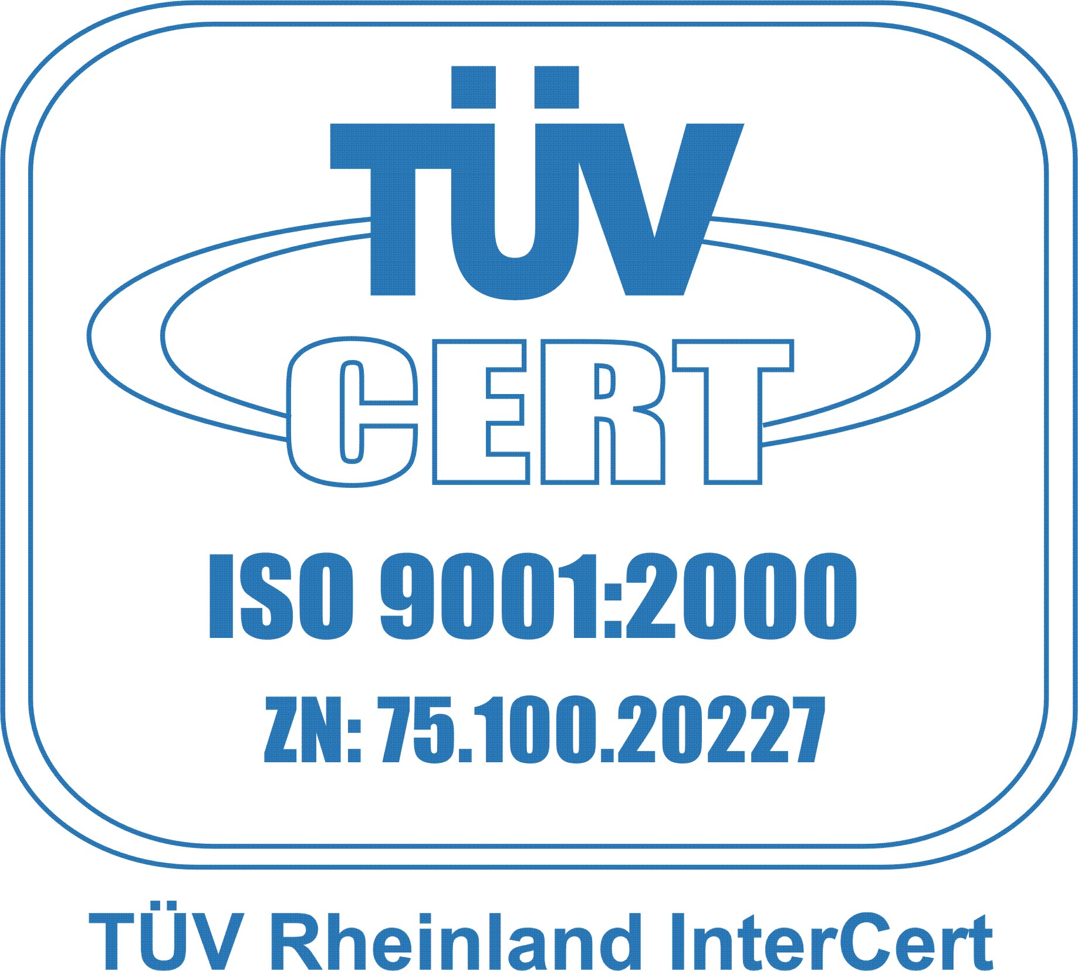
CONTRACTOR
S.C. BELEVION IMPEX S.R.L.

3 Doctor Clunet St., 050527 Bucharest, ROMANIA
Tel/fax: 00 40 21 410 31 32
E-mail: office@belevion.ro
www.belevion.ro

