VOLUME D11
GEOPHYSICAL INVESTIGATION
RESISTIVITY SURVEY

Volume | Km from | Km to | Task | Length | Survey Type
D01 | 800 | 1+300 | i | 0.5 | Seismic
D02 | 27+200 | 27+500 | i | 0.3 | Seismic
D03 | 28+400 | 28+600 | i | 0.2 | Seismic
D04 | 28+600 | 29+600 | i | 1 | Resistivity
D05 | 36+800 | 37+300 | i | 0.5 | Resistivity
D06 | 37+300 | 37+800 | i | 0.5 | Seismic
D07 | 37+800 | 38+900 | i | 1.2 | Resistivity
D08 | 10+200 | 10+700 | iii LLR | 0.5 | Seismic
D09 | 300 | 900 | iii | 0.6 | Resistivity
D10 | 900 | 1+300 | iii | 0.4 | Seismic
D11 | 1+300 | 2+700 | iii | 1.4 | Resistivity
D12 | 2+700 | 3+100 | iii | 0.4 | Seismic
D13 | 3+100 | 5+300 | iii | 3.2 | Resistivity
D14 | 8+500 | 11+000 | iii | 2.5 | Resistivity
D15 | 12+000 | 13+000 | iii | 1 | Resistivity
D16 | 15+000 | 18+000 | iii | 3 | Resistivity
D17 | 20+000 | 21+000 | iii | 1 | Resistivity
D18 | 25+200 | 25+900 | iii | 0.7 | Resistivity
D19 | 29+500 | 30+700 | iii | 1.2 | Resistivity
D20 | 36+400 | 36+800 | iii | 0.4 | Seismic
D21 | 38+600 | 39+300 | iii | 0.7 | Resistivity
D22 | 39+300 | 39+700 | iii | 0.4 | Seismic
D23 | 39+800 | 41+300 | iii | 0.5 | Resistivity
D24 | 43+200 | 43+500 | iii | 0.3 | Seismic
D25 | 51+700 | 55+300 | iii | 3.6 | Seismic
D26 | 68+600 | 69+800 | iii | 0.2 | Seismic
D27 | 70+800 | 71+600 | iii | 0.8 | Resistivity
D28 | 90+700 | 91+300 | iii | 0.6 | Seismic
D29 | 91+800 | 92+600 | iii | 0.8 | Resistivity
D30 | 96+200 | 98+200 | iii | 2 | Resistivity
D31 | 1+000 | 1400 | ii | 0.4 | Seismic
D32 | 9+000 | 10+000 | ii | 1 | Seismic
D33 | 14+500 | 14+900 | ii | 0.4 | Seismic
D34 | 20+900 | 21+600 | ii | 0.7 | Seismic
D35 | 27+300 | 27+700 | ii | 0.4 | Seismic
D36 | 29+500 | 29+900 | ii | 0.4 | Seismic
D37 | 32+000 | 32+400 | ii | 0.4 | Seismic
D38 | 27+700 | 29+000 | ii | 1.3 | Resistivity
D39 | 62+500 | 64+000 | ii | 1.5 | Seismic
D40 | 71+000 | 71+700 | ii | 0.7 | Seismic
D41 | 73+000 | 73+400 | ii | 0.4 | Seismic

General Information

Survey Line Parameters
Projected Parameters | Volume name | D30
Projected Parameters | Survey type | Resistivity
Projected Parameters | Task | iii
Projected Parameters | Km from | 96+200
Projected Parameters | Km to | 98+200
Projected Parameters | Length (km) | 2
Survey Parameters | Length (km) | Three Survey Lines; Total Length: 2.02  D30A (900 m), D30B (700 m) and D13C(400 m)
Survey Parameters | Maximum offset from projected line | 90 m
Survey Parameters | Data acquisition period | 05-06.09.2008, 23-24.10.2008
Survey Parameters | Weather condition | Hot/Cloudy, Cloudy/Rainy
Survey Parameters | Brief terrain description | Flat terrain covered by zones with dense vegetation and agriculture land
Notes:
- Because of Deva – Bejan – Branisca road this sector was divided into three survey lines
- Maximum offset and line position were constrained by access roads, steep slopes and heavy vegetation
See Annex 30/41 (Survey Line Location and Results)

Survey equipment
Data acquisition stage was completed using the following equipment:
- ZONGE, 2.5 kW – IP Transmitter
- SCINTREX IPR 12 – IP Receiver
- Non-polarizable Electrodes
Array geometry for D30A sector: pole-dipole
- 16 depth levels resolution
- 80 meters depth of investigation
- 20 meters station step
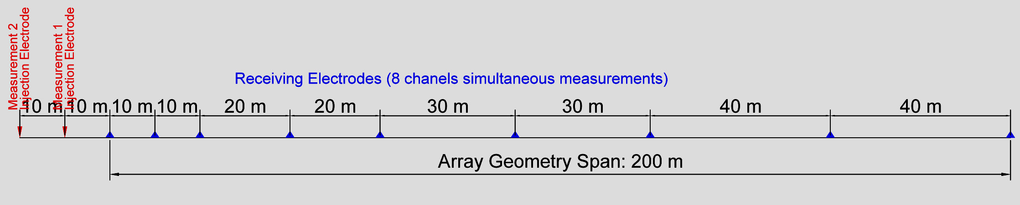
Array geometry for D30B and D30C sector: pole-dipole
- 16 depth levels resolution
- 40 meters depth of investigation
- 20 meters station step

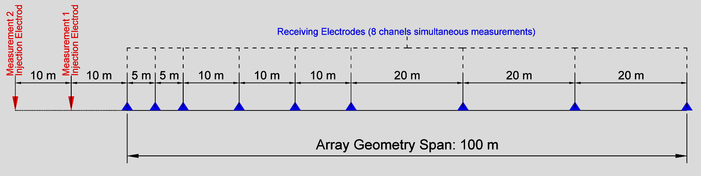

Data Acquisition Parameters

Measurement Parameters
Input signal: square wave (4s I+, 4s 0, 4s I-, 4s 0).
Additional chargeability measurements were recorded over 340-520 ms window span.

Quality Control
To insure reliability of acquired data several stages for quality control were applied to data processing workflow:
- Each measurement was averaged at over five cycles.
- To insure repeatability and reliability, up to 5% out of total measurements were repeated in the same station point;
- Quality control was applied in each stage of the processing workflow using specific programs and routines to filter any abnormalities found within raw data

Results
Results were organized as follows:
- Three Longitudinal Sections (See. Annex 30/41) covering all volume length containing:
  - Inverted Resistivity and Chargeability (Vertical and Horizontal Scale 1 : 1000)
  - Plan location of Survey Line and Projected Volume (Scale 1 : 5000)
  - Interpretation of physical parameters distribution
- Raw data available in several suitable formats
- Topographic data for each measurement location
- Inverted Result Data in suitable formats (easy to integrate into any follow up workflow).

Resistivity Survey Project Coordinator
Eng. Filip ONESCU

Report and Drawings prepared by
Eng. Filip ONESCU

Verified by:
Eng. Horia NISTOR

Approved by:
Eng. Dan ONESCU

